ASSIGNMENT 2

AIM 1:-Write a program to find mean, standard deviation, variance.

Code:-

h1=imread('tvr.tif');

h=im2double(h1);

sz=size(h);

sum=0;

v1=0;

v2=0;

for i=1:sz(1)

for j=1:sz(2)

sum=sum+h(i,j);

end

end

mn=sum/(sz(1)\*sz(2));

disp('Mean is::');

disp(mn);

for i=1:sz(1)

for j=1:sz(2)

v1=h(i,j)-mn;

v2=v2+v1;

end

end

varn=v2/((sz(1)\*sz(2))-1);

disp('Variance is::');

disp(varn);

disp('Standard Deviation is::');

disp(sqrt(double(varn)));

Output:-

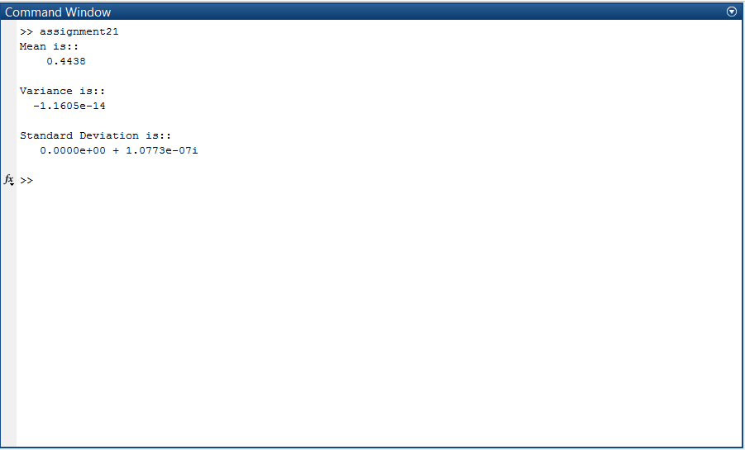

AIM 2:-Write a program which contains following functionalities.

1)Read Logical, Gray scale and Color image by selecting options 1,2 and 3.

2)Convert image into binary, grayscale image (if possible)

3)Separate r, g, b plane from color image and display it (if possible)

Code:-

% Read grayscale, color images

clear all;

clc;

close all;

t1=imread('lena.jpg'); %Orignal img

max=0;

countz=0;

count1=0;

grayc=0;

colorc=0;

num=input('PRESS 1:LOGICAL 2:GRAYSCALE 3:COLORED::');

sz=size(t1);

disp(ndims(t1))

if ndims(t1)==3

colorc=colorc+1;

elseif ndims(t1)==2

for i=1:sz(1)

for j=1:sz(2)

if t1(i,j)>1 & t1(i,j)<=255

grayc=grayc+1;

end

end

end

end

if num==3

if colorc>0

subplot(2,2,1)

imshow(t1);

t2=rgb2gray(t1);

subplot(2,2,2)

imshow(t2);

t3=im2bw(t1);

subplot(2,2,3)

imshow(t3);

title('ALL CONVERSIONS ARE POSSIBLE.')

elseif (colorc==0) & (grayc>0)

subplot(2,2,1)

imshow(t1);

t3=im2bw(t1);

subplot(2,2,2)

imshow(t3);

title('HERE SELECTED IMAGE IS GRAYSCALE SO ONLY BINARY IS POSSIBLE.')

elseif (colorc==0) & (grayc==0)

subplot(2,2,1)

imshow(t1);

end

elseif num==2

if colorc>0

disp('INVALID IMAGE')

elseif (colorc==0) & (grayc>0)

subplot(2,2,1)

imshow(t1);

t3=im2bw(t1);

subplot(2,2,2)

imshow(t3);

title('HERE SELECTED IMAGE IS GRAYSCALE SO ONLY BINARY IS POSSIBLE.')

elseif (colorc==0) & (grayc==0)

subplot(2,2,1)

imshow(t1);

end

elseif num==1

if colorc>0

disp('INVALID IMAGE')

elseif (colorc==0) & (grayc>0)

disp('INVALID IMAGE')

elseif (colorc==0) & (grayc==0)

subplot(2,2,1)

imshow(t1);

title('HERE SELECTED IMAGE IS BINARY SO NO HIGHER CONVERSIONS ARE POSSIBLE.')

end

end

a=imread('898.jpg');

[r c d] = size(a);

red= a(:,:,1);

green = a(:,:,2);

blue = a(:,:,3);

plane = zeros(r,c);

R = cat(3,red,plane,plane);

G = cat(3,plane,green,plane);

B = cat(3,plane,plane,blue);

subplot(2,2,1)

imshow(a);

subplot(2,2,2)

imshow(R);

subplot(2,2,3)

imshow(G);

subplot(2,2,4)

imshow(B);

Output:-

